Exp 1 – Greatest among three numbers
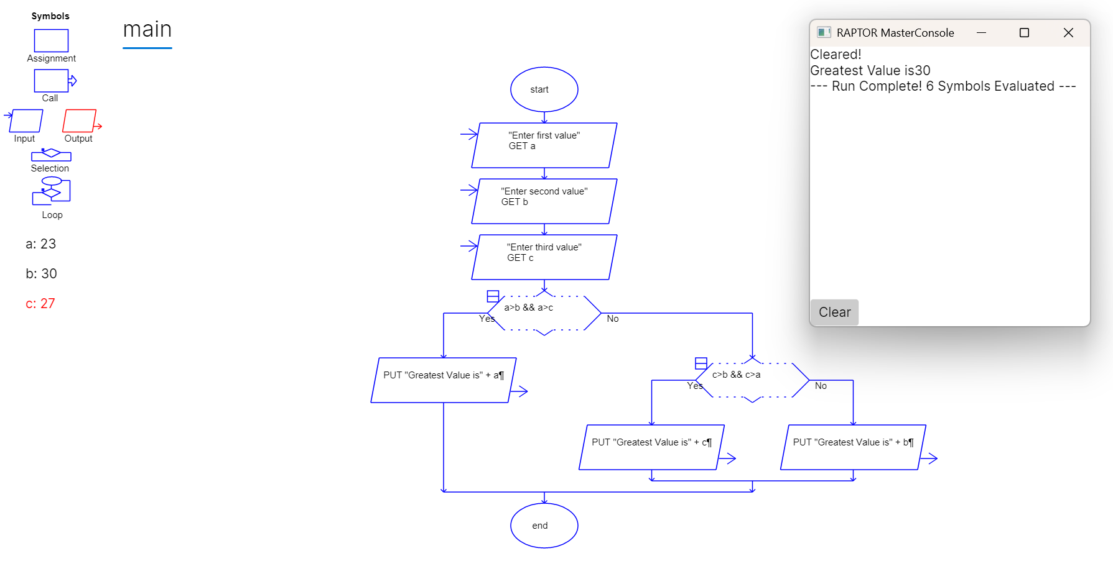

EXPT 2
ARMSTRONG NUMBER
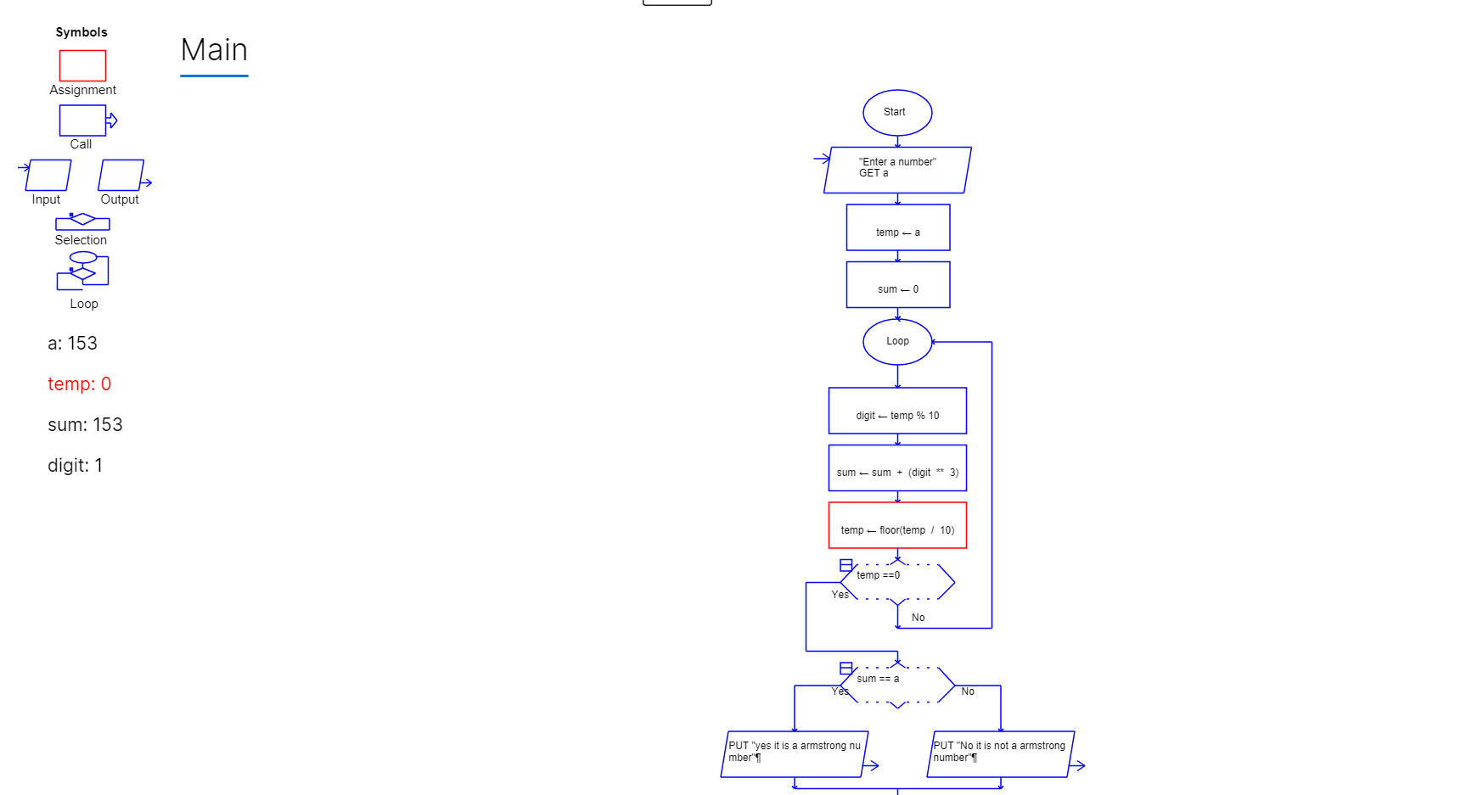

EXPT 3
STRING COUNT
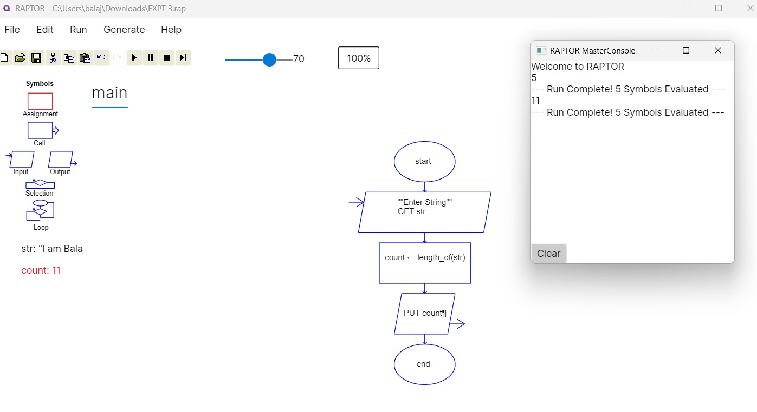
EXPT 4
FACTORIAL OF A NUMBER

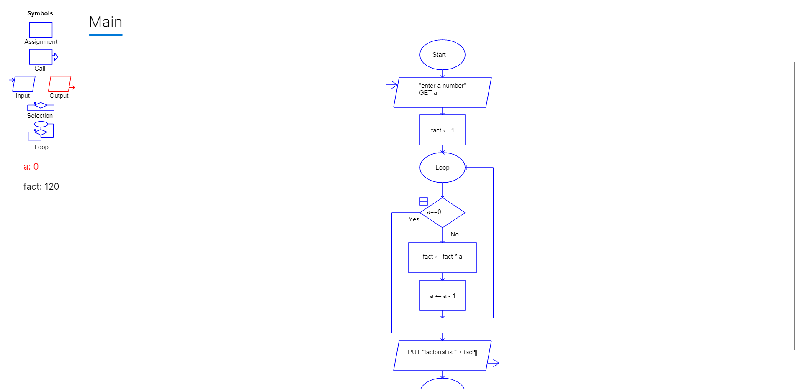

EXPT 5
CYCLOMATIC COMPLEXITY
